

**Creating a 4 Color Bitmap for the RFLKT Display in Adobe Photoshop CS6**

The RFLKT supports 2 bit colors (4 colors in total) as shown below:

|  |  |  |
| --- | --- | --- |
| **Color** | **Hex code (RFLKT)** | **Hex Code (RGB)** |
| White | 0x03 | 0xFFFFFF |
| Light Gray | 0x02 | 0x696969 |
| Dark Gray | 0x01 | 0xCCCCCC |
| Black | 0x00 | 0x000000 |

1. Create a new Photoshop document of your chosen size. Our chosen icon size is 18x18px, however the RFLKT supports bitmaps up to the full screen size of 128px x 128px.
2. Set the pixel aspect ratio to 0.67 in View->Pixel Aspect Ratio->Custom Pixel Aspect Ratio… Factor: 0.67.

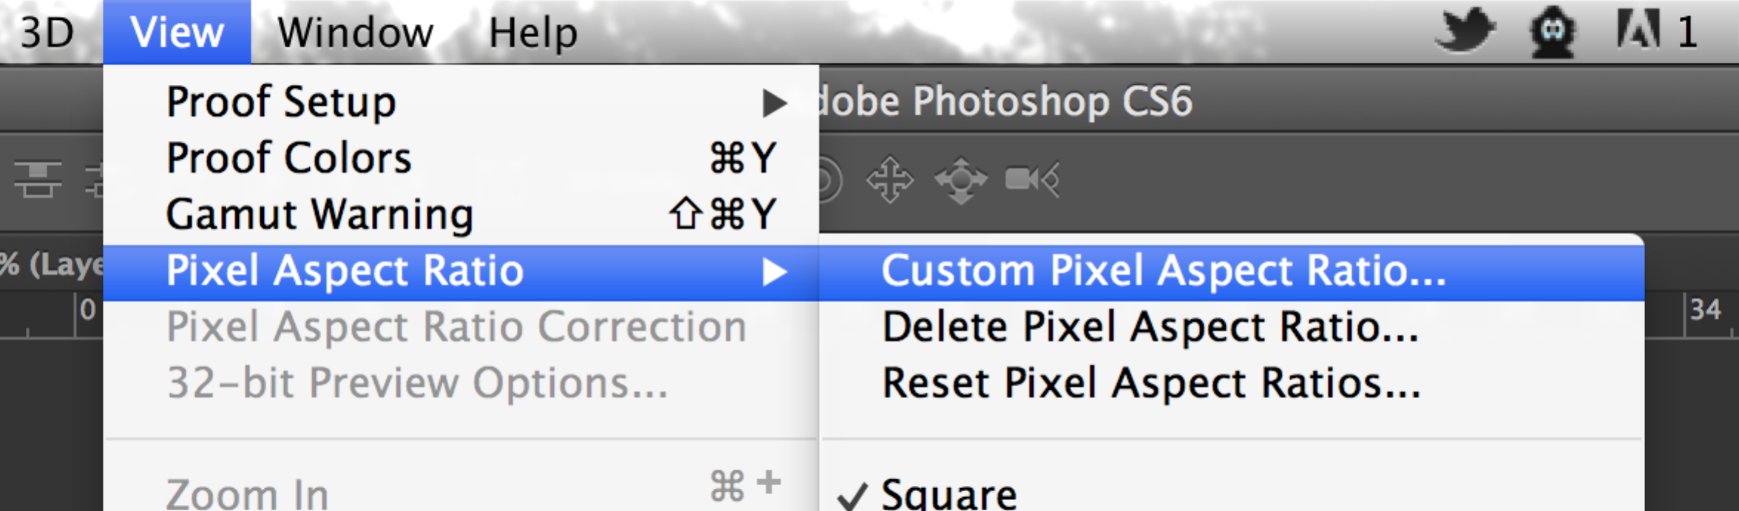

1. Set the image to Indexed Color in Image🡪Mode->Indexed Color

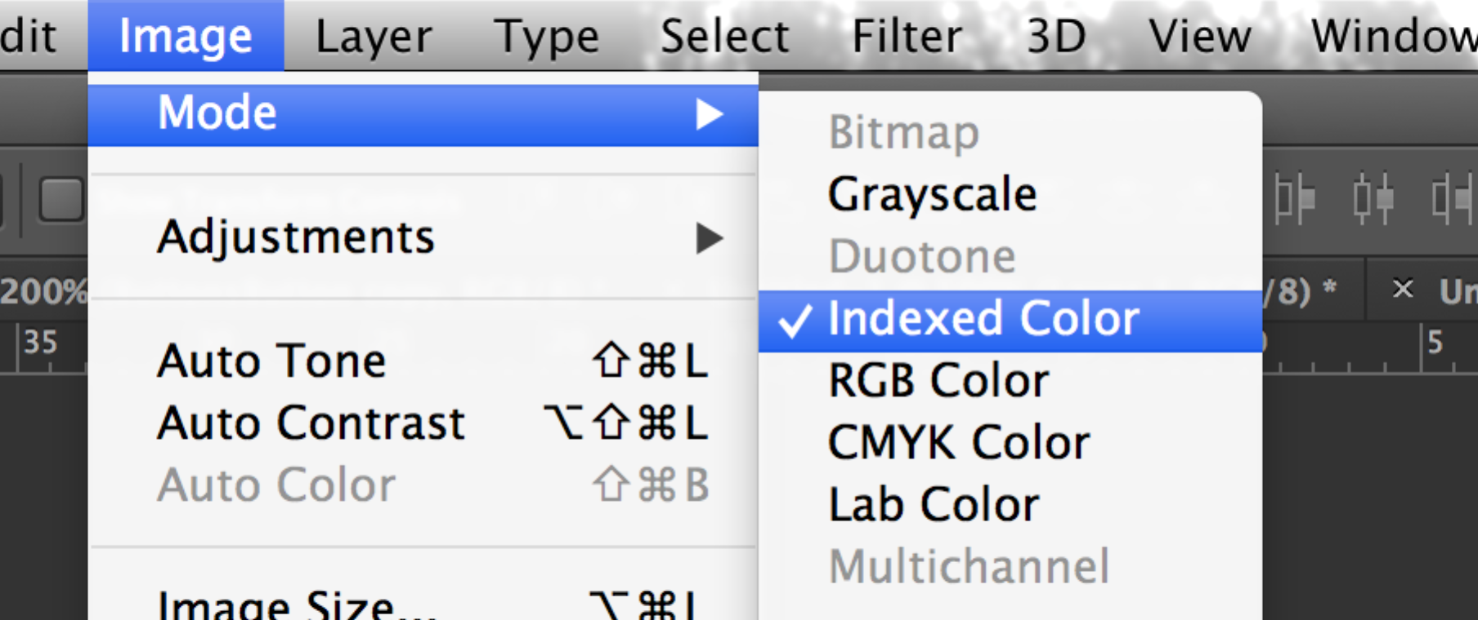

1. Select “Custom…” Palette:

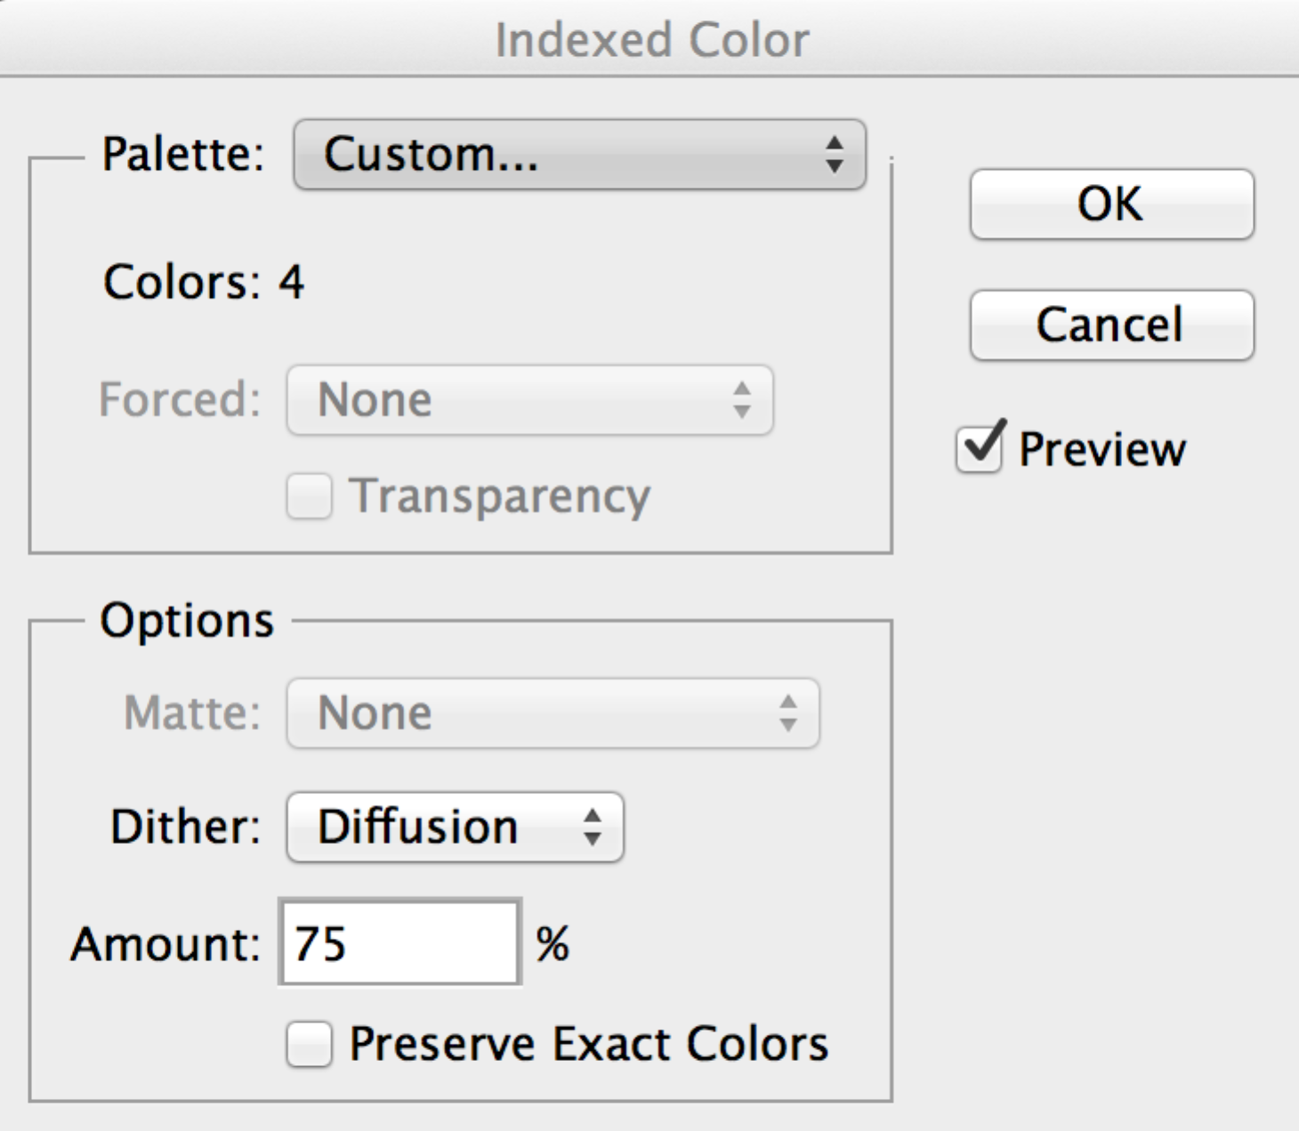

1. Set the color palette to the 4 colors listed above, in the following order: Black (0x000000), Dark Grey (0x696969), Light Grey (0xCCCCCC), White (0xFFFFFF). Alternatively, import the supplied RFLKT Color Palette (RFLKTColorTable.act).

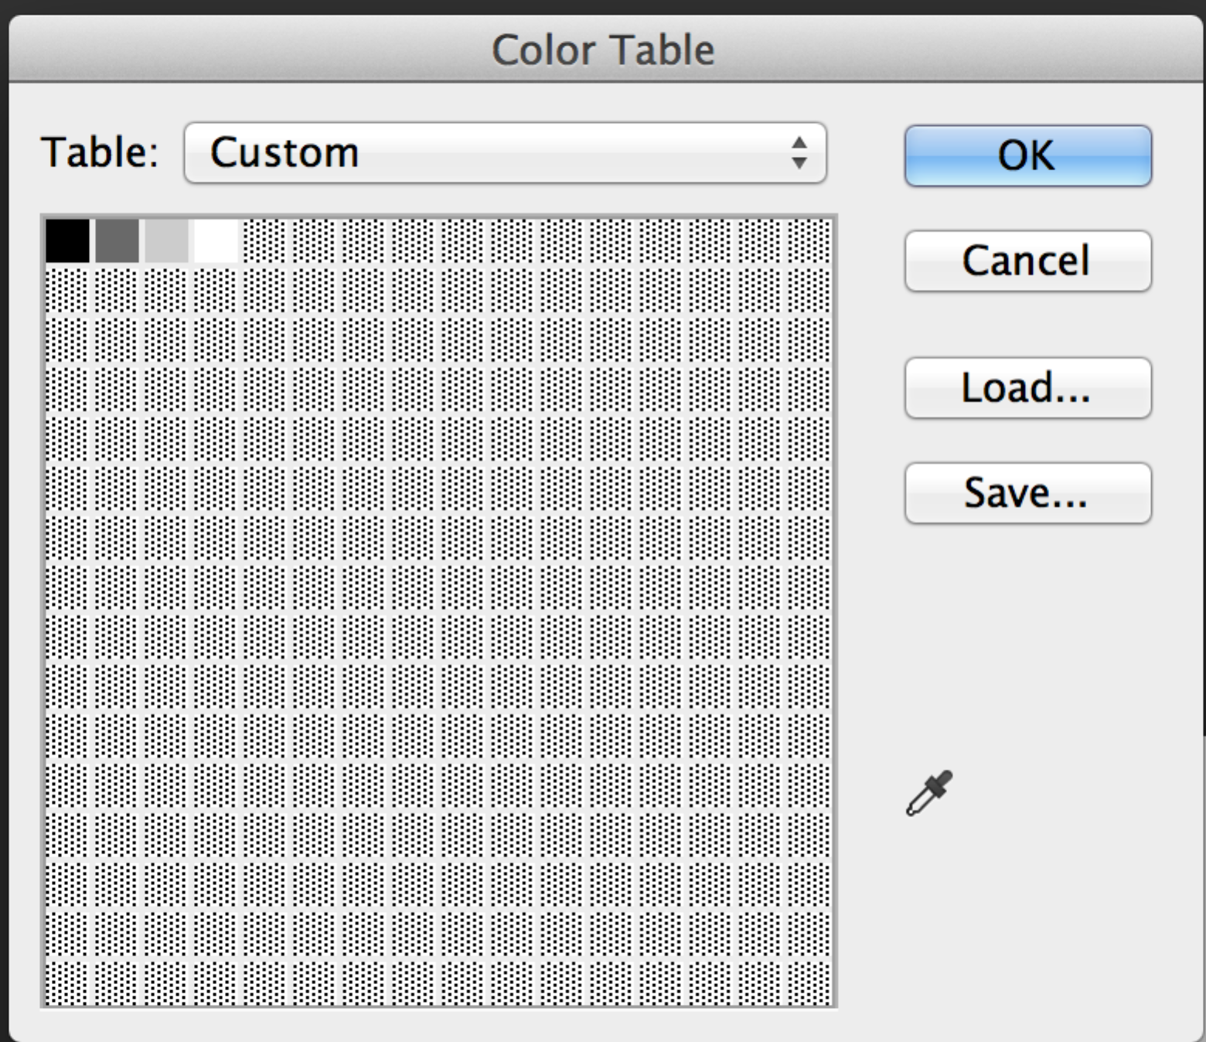

1. Draw or paste your image.
2. Save the file as a Bitmap (File->Save As. Format:BMP).
3. Use the WFBitmapConverter to create the encoded strings